Creating Trail Maps with QGIS, Strava, and ArcGIS API for JavaScript 4

# Prerequisite Software

## QGIS Setup

QGIS is an open source GIS desktop application. Easy to download and use. We are going to use it to query OpenStreetMap and create/edit our trail data.

### Installation

1. Go to: <https://qgis.org>
2. Click the Download Now button.
3. Choose QGIS Standalone Installer Version 3.4. (64-bit)
4. Run the executable. Choose all the defaults.

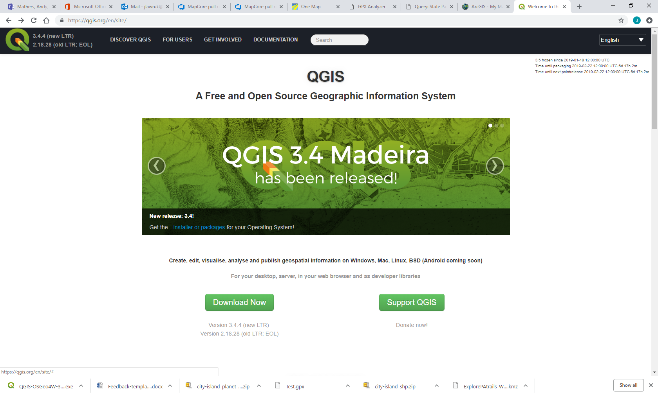 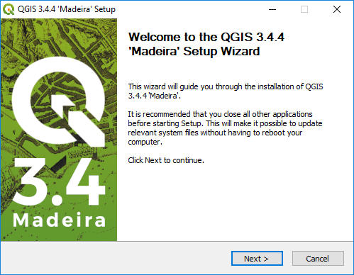

### Add QuickOSM Plugin

OpenStreetMap (OSM) is the crowd-sourced free and editable map data of the world.

1. In the top menu, select Plugins, Manage and Install Plugins.
2. Search for OpenStreetMap to narrow the list of plugins.
3. Select and Install QuickOSM.

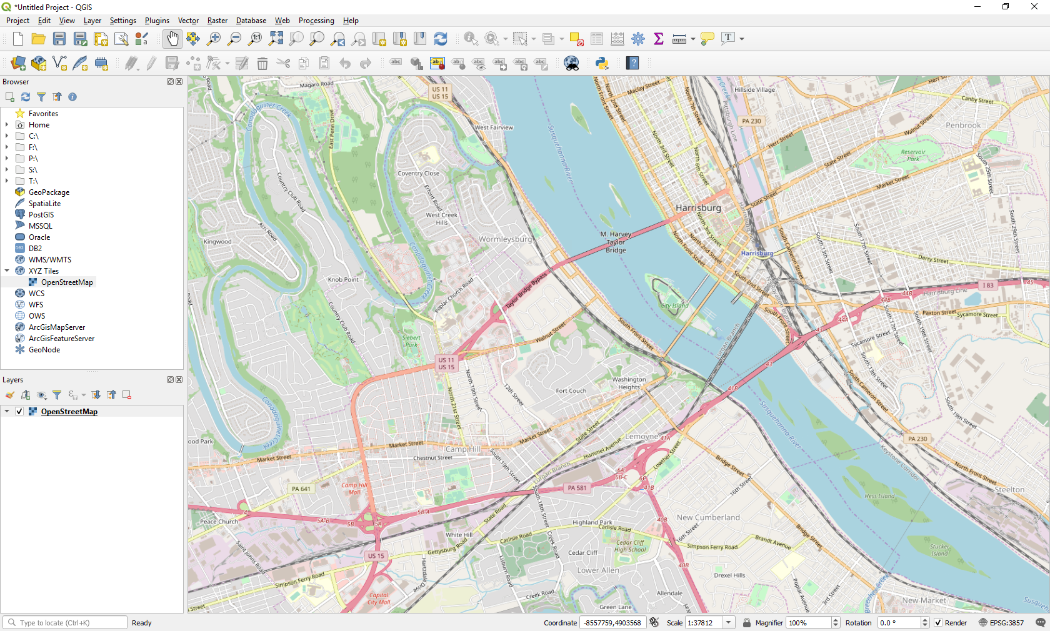

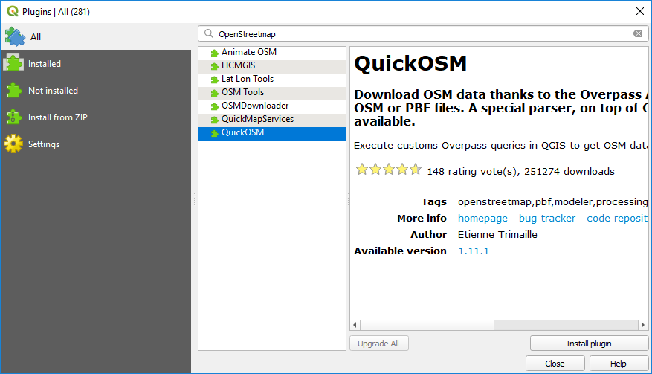

## Visual Studio Code Setup

### Installation

1. Go to: <https://code.visualstudio.com/>
2. Click the green Download button.
3. Select the Windows installer.
4. Run through the defaults.

### Add Live Server Extension

1. Open the VS Code.
2. On the left navigation bar, click the Extensions (box in a box) menu item.
3. Search for “live server.”
4. Click the green Install button.

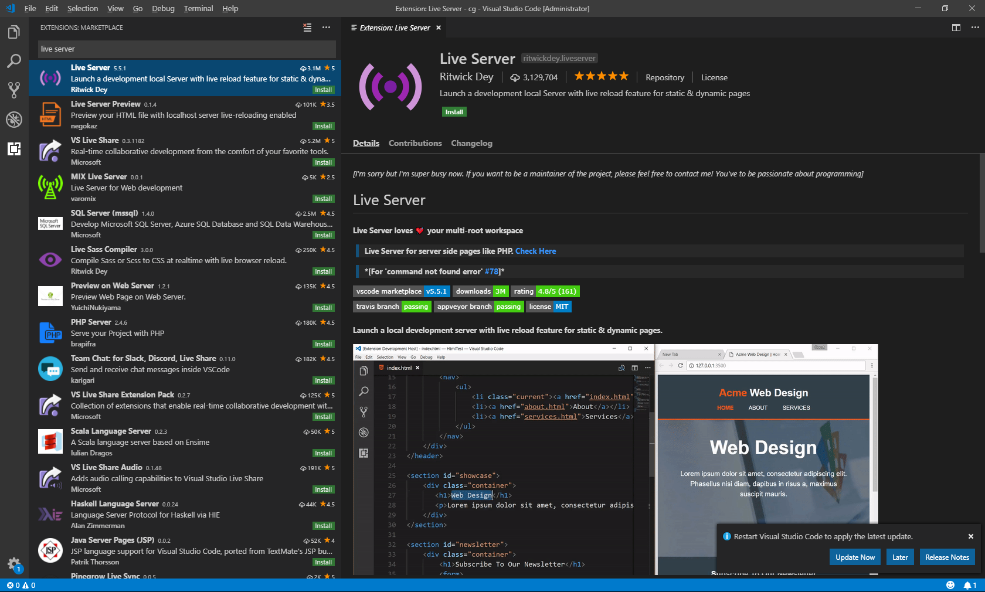

# Collecting Trail Data

## Boyd Big Tree Preserve

Query OpenStreetMap to get a GeoJSON file of the trails in Boyd Big Tree Preserve.

### Query OpenStreetMap

1. Open QGIS Desktop.
2. On the left browser navigation, expand XYZ Tiles and select OpenStreetMap.
3. Use the mouse to zoom into the Boyd Big Tree Preserve area north of Harrisburg.
4. In the top menu, under Vector, select QuickOSM.
5. Enter the Key: **highway**
6. Enter the Value: **path**
7. Change the In to: **Canvas Extent**.
8. Under Advanced, choose only lines on the right.
9. Enter an output directory and a file prefix.
10. Click the Run query button.
11. Close QuickOSM.

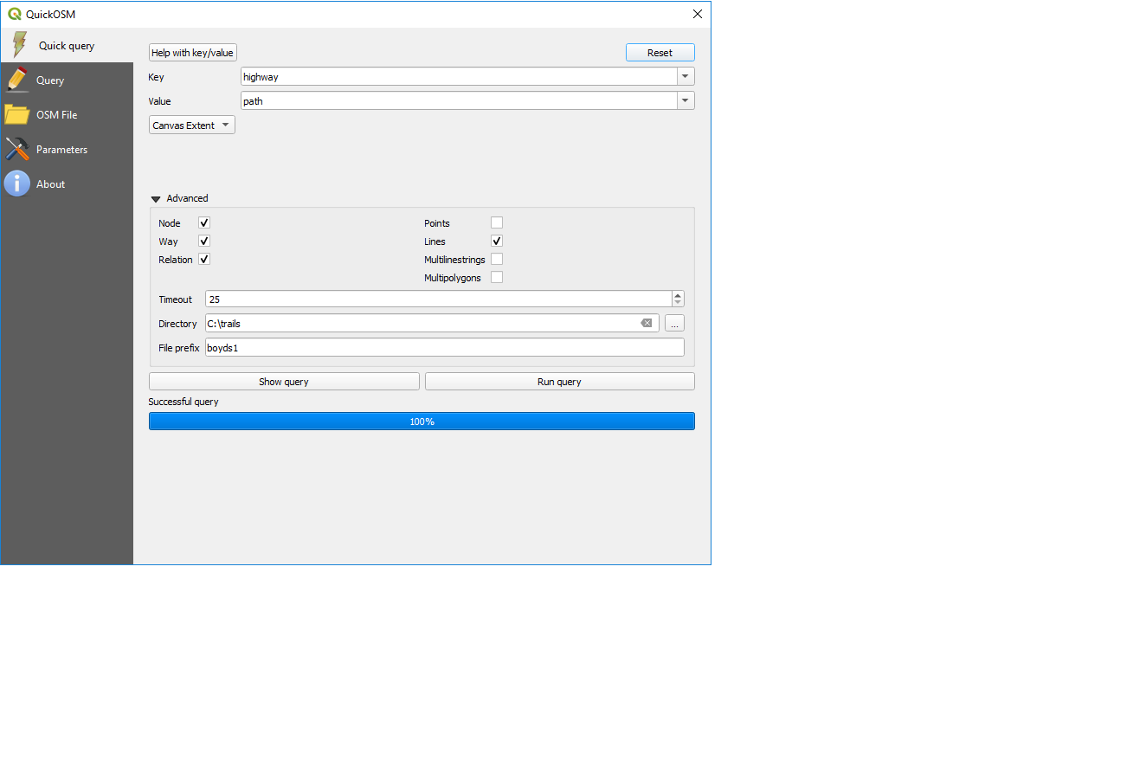

1. Inspect in a text editor the .geojson file created in your output directory.
2. On the left in the layers section, notice the new layer created in QGIS.
3. Click the line symbol to edit symbology.
4. Change the width to 1 and the color to red to make the layer more visible.
5. Click OK.

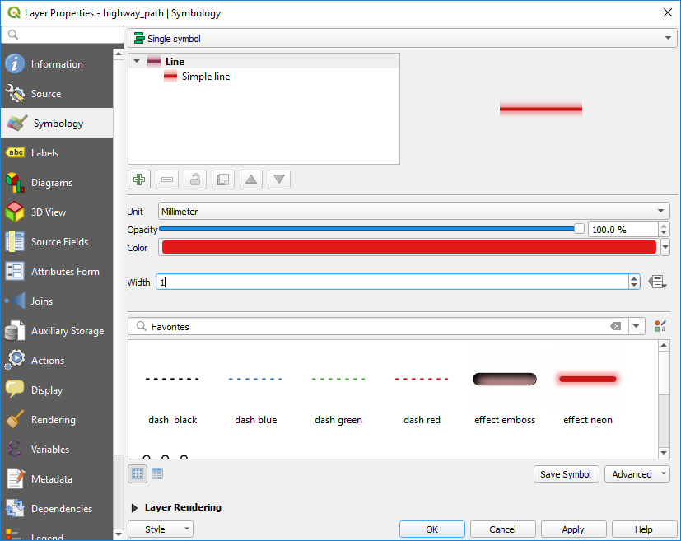

## Greenbelt

Query OpenStreetMap to get a GeoJSON file of the Harrisburg Greenbelt. Add additional line features to fill in the gaps.

### Query OpenStreetMap

1. Open QGIS Desktop
2. On the left browser navigation, expand XYZ Tiles and select OpenStreetMap
3. Use the mouse to zoom into Harrisburg.
4. In the top menu, under Vector, select QuickOSM…
5. Enter the Key: **name**.
6. Enter the Value: **Capital Area Greenbelt**.
7. Change the In to **Canvas Extent**.
8. Under Advanced, choose only lines on the right.
9. Enter an output directory and a file prefix.
10. Click the Run query button.
11. Close QuickOSM.

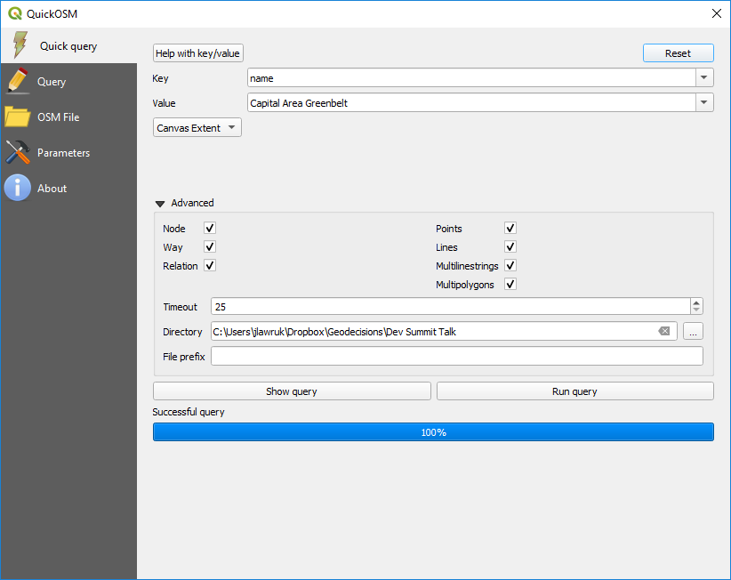

1. On the left in the layers section, click the line symbol to edit symbology.
2. Change the width to 1 and the color to green to make the layer more visible.
3. Click OK.

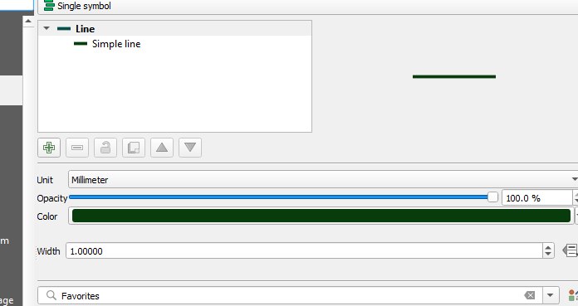

### Adding and Editing Features

1. Zoom into an area where you want to add features.
2. Select the layer in the Layers list.
3. Click on the Pencil to Toggle into editing mode.
4. Click the Add Line Feature button.
5. Click on the map to start drawing a line feature.
6. Keep clicking points to add segments to the feature.
7. Right click to finish a feature.
8. Enter any feature attribute data as desired.
9. Click Ok.

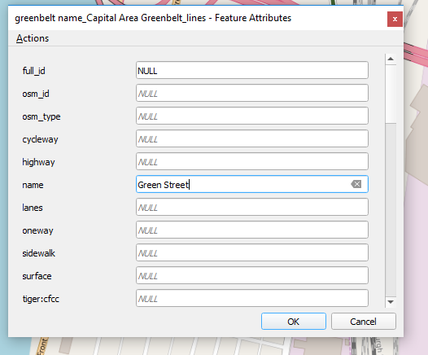

1. Click on the Vertex tool to edit the lines as needed. 
2. Click the Pencil button to toggle out of edit mode.
3. When asked if you want to save changes, click Save.
4. Notice the geojson file has been updated.

## Trails from Strava

Export trail data from Strava and convert the data to GeoJSON format. This assumes you have a Strava account with previous activities recorded.

### Export GPX Files from Strava

1. Login to Strava.
2. Select your training log.
3. Pick an activity from the calendar.
4. Under Overview, click on the Actions (Wrench) button.
5. Select Export GPX. The GPX file should then download to your computer.
6. Open the GPX file in a text editor. Notice the date stamp, coordinates, and elevation.

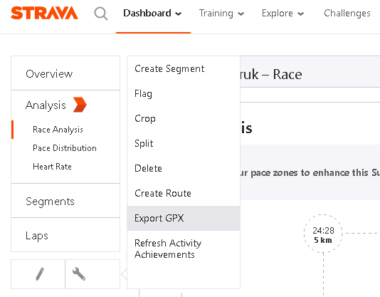

1. Go back to the Actions (Wrench) button.
2. Select Create Route.
3. Click the orange Save button.
4. Give the route a name, mark it private, and click Save.
5. Click View my Route.
6. Click the Export GPX button to download the route file.

### Convert the GPX file to GeoJSON

1. Go to: <https://mygeodata.cloud/converter/gpx-to-geojson>
2. Upload your GPX file to convert.
3. When asked what input layers, select only tracks.
4. Click Convert Now.
5. Get the downloaded tracks.geojson file.
6. Inspect the tracks.geojson file in a text editor. Notice all the coordinates in one feature.

# Displaying Trail Data on an ArcGIS Map

## Download Demo files from Github Repository

1. Go to the Url: <https://github.com/jimlawruk/geodev2019>
2. Clone or download the Repository into a geodev2019 folder on your desktop.
3. Copy the 0-blankMap.html to a new file called demo.html.

## Blank Map

Create a simple map using the ESRI ArcGIS JS API.

1. Open Visual Studio Code.
2. In the top menu, select File, Open Folder. Select the geodev2019 folder.
3. In the explorer (usually on the left), select the demo.html file.
4. Review the code responsible for a simple map.
5. In the bottom of the editor, click the Go Live link to launch the html page in a browser.

require([

"esri/Map",

"esri/views/MapView"

], function(Map, MapView) {

var map = new Map({

basemap: "streets"

});

var view = new MapView({

container: "viewDiv",

map: map,

zoom: 14,

center: [-76.87, 40.26]

});

});

## Add Basemap Toggle

Allows the user to switch from a streets map to a satellite imagery map.

1. In the explorer on the left, select the 1-basemapToggleSnippet.txt file.
2. Follow the steps copying the code snippets to the demo.html.

"esri/widgets/BasemapToggle",

], function(Map, MapView, BasemapToggle) {

var toggle = new BasemapToggle({

titleVisible: true,

view: view

});

view.ui.add(toggle, "bottom-right");

## Add Layer List

Add a layer list to the map which allows the user to turn on/off the layers.

1. In the explorer on the left, select the 2-layerListSnippet.txt file.
2. Follow the steps copying the code snippets to demo.html.

"esri/widgets/LayerList",

var layerList = new LayerList({

view: view

});

view.ui.add(layerList, "top-right");

## Add Graphics Layer Setup Code

Adds several modules to process GeoJSON files and convert the contents to graphics layers.

1. In the explorer, select the 3-geoJsonLayerSetupSnippet.txt file.
2. Follow the steps copying the code snippets to demo.html.
3. Examine the code contents.
4. Notice the addGeoJSONLayer method accepts 3 parameters: (filename, title, colorArray)
5. Notice the code does the following:
   1. Requests the contents of a GeoJSON filename.
   2. Converts the GeoJSON features to ESRI Polyline Graphics with the color specified.
   3. Adds the graphics to a new GraphicsLayer with the specified title.
   4. Adds the new graphics layer to a map.

## Add the GeoJSON Layers

Add a layer for each of the GeoJSON files created previously.

addGeoJSONLayer("boyd.geojson", "Boyds", [200, 0, 0, 1]);

addGeoJSONLayer("greenbelt.geojson", "Greenbelt", [0, 200, 0, 1]);

addGeoJSONLayer("pinchot.geojson", "Pinchot", [0, 0, 200, 1]);

1. In the explorer, select the 4-addGeoJsonLayersSnippet.txt file.
2. Follow the steps copying the code snippets to demo.html.

## Add a DCNR Trails Feature Layer

Add a DCNR trails FeatureLayer to the map.

1. Go to the DCNR ArcServer: <https://www.gis.dcnr.state.pa.us/agsprod/rest/services/> Notice the various layers available.
2. Navigate to Parks/State_Parks/MapServer/4

Parks/State_Parks/MapServer/4 <https://www.gis.dcnr.state.pa.us/agsprod/rest/services/Parks/State_Parks/MapServer/4>

1. In the explorer on the left, select the 5-DCNRLayerSnippet.txt file.
2. Follow the steps copying the code snippets to the demo.html

## Adding Locate Indicator

Add a locate indicator to the map.

1. In the explorer on the left, select the 6-locateSnippet.txt file.
2. Follow the steps copying the code snippets to the demo.html

"esri/widgets/Locate",

var locateBtn = new Locate({

view: view

});

view.ui.add(locateBtn, "top-left");

## Finished Demo Map

Your finished map should contain a basemap toggle, a layer list, three GeoJSON layers, two feature layers from DCNR, and a locate button.

